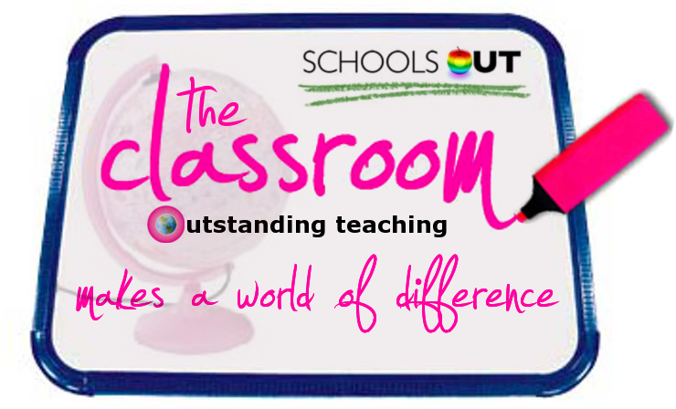
Enter The Classroom:
www.the-classroom.org.uk

This lesson usualises
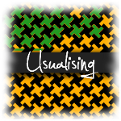
EYFS Aspect: Personal, Social and Emotional Development:

Lesson Title: Group: Teacher: Date:
URL for ‘All Kinds of Families are Special’ and other EYFS lessons:
http://www.schools-out.org.uk/classroom/category/the-materials-to-use/by-key-stage/eyfs/eyfs-schools-out-lesson-plans
National Curriculum Key Stage and Targets: EYFS Reception 4-5yrs
NC Targets (see Teaching and Learning Objectives)
Seeking Relationships and Sense of Community
The National Strategies website, NS Online (NSO), closed 29/6/2011.The contents of this site has been copied to the National Archives where they will remain accessible.
Cross-Curricular Elements: Numeracy Shape and Colour
Further Learning Opportunities: Family activities from http://www.dltkkids.com/crafts/miscellaneous/families.htm

Lesson Area | Timing | Teaching and Learning
Focus the Learning - Learning Objectives: Tell students what they will learn, how it relates to their experience, the standard at which they are working and write key vocabulary on the board. |  | (set from the Early Learning Goals Knowledge and Understanding of the World) – archived content  By the end of the lesson:  All students will have a developing respect for their own cultures and beliefs and those of other people e.g must know that all families are different  Most students will respond to significant experiences, showing a range of feelings when appropriate e.g. they should be able to talk about what makes their family good  Some students will work as part of a group or class, taking turns and sharing fairly, understanding that there needs to be agreed values and codes of behaviour for groups of people, including adults and children, to work together harmoniously. e.g could know that different families work in different ways and that this isn’t a problem
Begin the Learning – Starter: Present new information using Visual, Auditory and Kinaesthetic methods. | 15  Mins | Carpet Time  You should have set up the front of your carpet space and stuck two or three families supplied around your board (or do the lesson in a circle and have them all in the middle). Ten families are included. They are identified by symbols (so you know what goes with what).  Today we are going to talk about different families. We are going to use all these different people and animals to help us do this.  These cards show us lots of different families. Who can make a family for me from these cards? Ask for a volunteer to come up and make one of the families. Encourage them to use the symbols or complete one of the families they know (e.g. Peppa Pig or Wallace and Gromit)  Can you draw your family for me? Ask the children to draw their family on their whiteboard.  What’s good about your family? How does being in your family make you feel?
Continue the Learning – Activities: This is the main part of the lesson. Provide a variety of challenging, differentiated VAK tasks / activities, meeting the needs of all students and all abilities.  Activity / Apply / Review  New activity / Apply / Review | Part 1  15mins  Part 2  20mins | Part 1: Reading Story  Today we are going to learn about a family of penguins. The child penguin in this family is called Tango.  Read story.  Ask a child to come up and make the family from the story using the penguin cards (Roy, Silo, Tango and the Zookeeper).  What things were good about this family?  Part 2: Group game  In groups (at tables) we are going to play ‘happy families’. The aim is to make as many families as you can. You know which cards go together because they have shapes on (like the ones on the board).  Rules of the Game  Each child has four cards and a pile of cards is put in the middle. Each child needs to make as many families as they can. When they have made a whole family (4 cards) they should put the cards down on the table in front of them.  When it is your turn you should ask another player for a card you need e.g. do you have any triangle cards?  If they do, they have to give them to the player who asked, if they don’t have any the player should pick up a card from the pile. The game ends when all the cards have been made into families.  (In a lower ability group, you may like to play the game as a class by pinning one character from each family on the board as a starter.) Then ask the children to come up and stick their card up to make rows of families which you can then discuss.
Supporting / Developing the Learning – Differentiation:  Where appropriate, identify students and the methods of support and extension to be used. Include support staff meeting notes. |  | Students / Target groups likely to need support:  Some groups of children may need support to play the game, but you can use it as often as you like as a standalone activity so that children become accustomed to playing it. Some groups may require teacher/TA/ Nursery Nurse support to learn the rules of the game. | Students likely to need extension work:  Gifted and Talented students could be given blank master cards so that they can design their own families and use them as part of the game.
Celebrating the Learning – Plenary: Students demonstrate in some way what they have learned. Recognition of progress. Refer back to Learning Objectives. | 10  Mins | Circle time  All families are different. They can be made up of people from different shapes, sizes, cultures, races and relationships. Families are made when people who love each other want to care for each other. together. They don’t have to live together to be a family.  What is special about your family? Why do you like it?  Go around the circle and accept one answer from each child.
Extend / Reinforce the Learning: |  | Worksheet One- My family.
Management of Resources  Identify which resources are to be used and how. Include the use of new technology and the use of other supporting adults. |  | This lesson is centred around sets of laminated cards, in a kind of contemporary take on ‘happy families’. Some of the families should be identifiable to children, but some are fictional.  Each child will need an individual whiteboard and pen for the starter activity.  For the second main activity each group will need a set of cards to play ‘happy families’. You can alter the number of families you give each group dependant on the number of players and the abilities/ages of the children involved.  You will need a copy of the book And Tango Makes Three which is available on Amazon (if you cannot get hold of the book lengthen the second game exercise)
Equal Opportunities & Social / Moral / Cultural considerations  Identify any relevant aspects of the lesson which develop pupil understanding, skills and knowledge in these areas. |  | This session talks about families as being happy and loving places. In a realistic world we have to accept that for some children this is not the case. Adults supporting this group should be aware of the potential for disclosures arising from this session and completely accepting of the difference of families (for instance a family where a parent is in prison, or a foster family). It is very important that staff ensure that all families are equally valued in the session.
Health and Safety Considerations  Identify the major Health and Safety considerations and what needs to be done to ensure maximum safety. |  | Your school’s normal FS classroom H&S risk assessments will apply.

